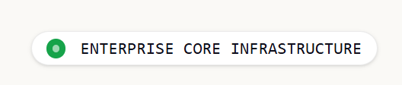
INDUSTRY SOLUTIONS

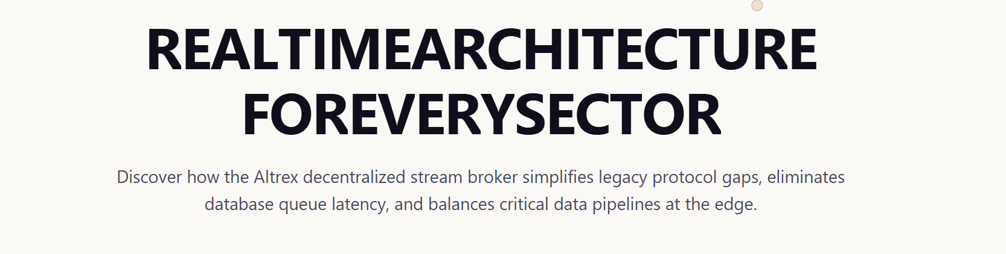
DIGITAL OPERATIONS FOR EVERY INDUSTRY
Purpose-built solutions for energy, utilities, manufacturing, transportation, and critical infrastructure—delivering real-time visibility, operational intelligence, and enterprise-scale automation.

CITY GAS DISTRIBUTION (CGD)
Tagline - "Real-Time Monitoring & Intelligence Across the Gas Distribution Network"
Description - Monitor CGS, DRS, CNG stations, pipelines, and distribution networks through a unified platform combining SCADA, telemetry, GIS, asset management, alarms, and operational analytics.
THE OPERATIONAL CHALLENGE- Managing geographically distributed gas infrastructure requires continuous monitoring of pressure, flow, equipment health, and operational events across thousands of assets.
THE ALTREX DIGITAL SOLUTION - Altrex provides end-to-end visibility across the CGD network, integrating field telemetry, GIS mapping, asset management, alarm monitoring, dashboards, and enterprise reporting within a single operational platform.
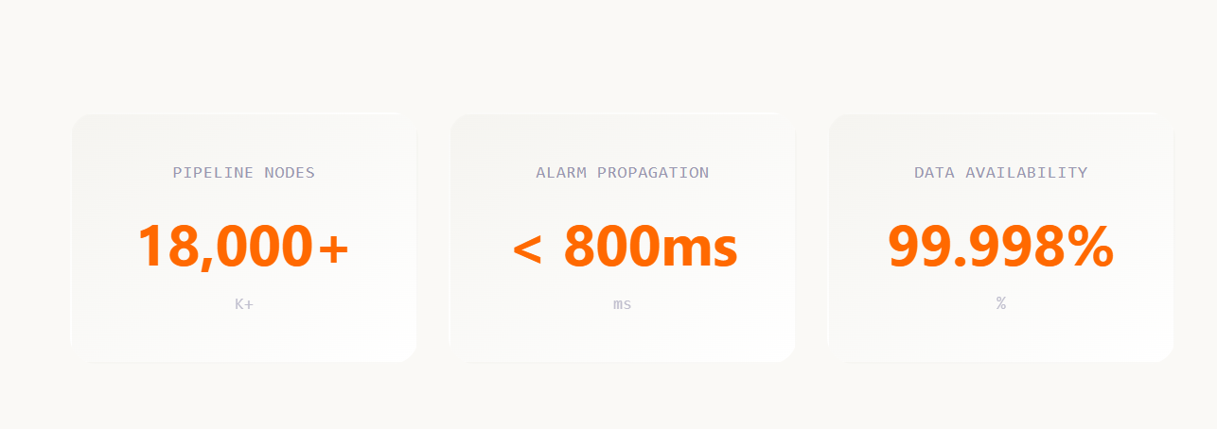
5,000+
Connected Assets
24x7
Operational Visibility
99.99%
Platform Availability

STEEL & METAL PROCESSING
"Operational Visibility Across Production, Utilities, and Energy Systems"
Description - Monitor production processes, utility systems, energy consumption, equipment health, and plant performance through centralized industrial intelligence.
THE OPERATIONAL CHALLENGE- Steel plants operate highly interconnected production processes where downtime, energy inefficiencies, and equipment failures directly impact productivity and profitability.
THE ALTREX DIGITAL SOLUTION - Altrex unifies plant telemetry, energy monitoring, asset performance, alarms, analytics, and production KPIs into a centralized operational intelligence platform.
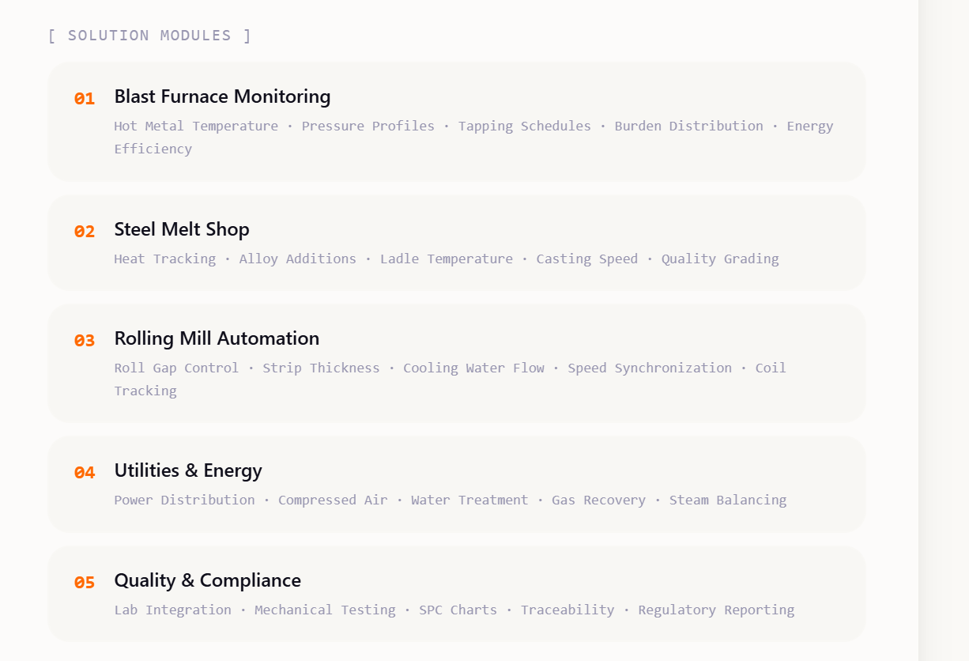
05 Asset Performance
Maintenance Analytics
Equipment Reliability
Condition Monitoring
Lifecycle Management
500+
Production Assets
15%
Energy Optimization
99.9%
Operational Availability

OIL & FUEL DISTRIBUTION
Tagline - "Real-Time Network Intelligence Across Depots, Terminals & Retail Fuel Networks"
Description - Oil Marketing Companies operate extensive networks of refineries, terminals, depots, tank farms, transportation fleets, and retail fuel stations requiring continuous operational visibility, inventory control, and asset monitoring.
THE OPERATIONAL CHALLENGE- Managing fuel inventory, retail operations, logistics movements, and distributed infrastructure across thousands of locations requires reliable real-time monitoring, reconciliation, and centralized operational control.
THE ALTREX DIGITAL SOLUTION - Altrex unifies tank monitoring, ATG integration, fuel station operations, fleet tracking, asset management, alarms, analytics, and enterprise reporting into a single operational platform.

10,000+
Connected Fuel Assets
24x7
Operational Visibility
99.99%
Inventory Data Availability

DISCRETE MANUFACTURING
Tagline - "Smart Manufacturing Through Connected Operations & Real-Time Intelligence"
Description - Monitor production lines, machines, utilities, and quality processes through a unified platform that delivers real-time visibility, operational analytics, and asset performance intelligence.
THE OPERATIONAL CHALLENGE - Manufacturing facilities require continuous visibility into production, equipment health, quality metrics, and operational performance to minimize downtime and maximize productivity.
THE ALTREX DIGITAL SOLUTION - Altrex integrates machine data, production KPIs, asset monitoring, quality management, alarms, analytics, and reporting into a single industrial operations platform.
85%+
Average OEE
20%
Downtime Reduction
15%
Efficiency Improvement

WIND ENERGY OPERATIONS
Tagline - "Real-Time Wind Farm Performance & Asset Intelligence"
Description - Monitor wind turbines, substations, and generation assets through a centralized platform delivering real-time visibility, performance analytics, condition monitoring, and operational intelligence.
THE OPERATIONAL CHALLENGE - Wind farm operators must manage geographically distributed assets, maximize energy production, reduce unplanned downtime, and ensure continuous visibility into turbine performance and equipment health.
THE ALTREX DIGITAL SOLUTION - Altrex integrates SCADA systems, condition monitoring, generation analytics, asset management, alarms, and predictive maintenance into a unified renewable energy operations platform.

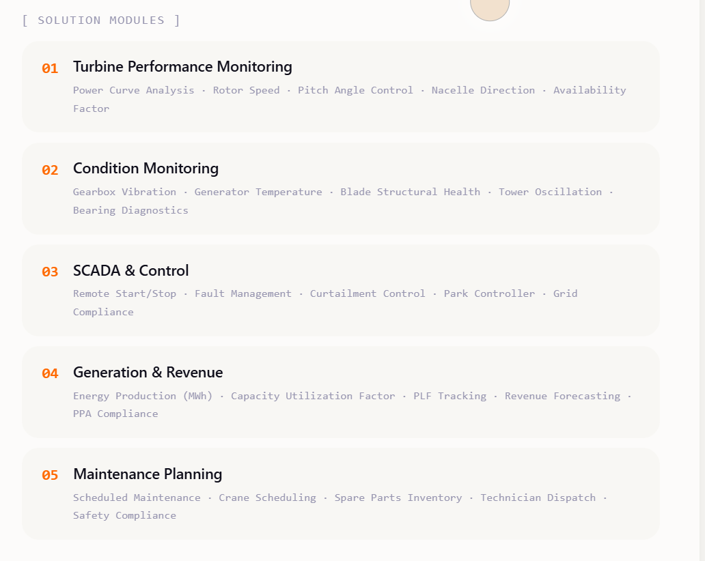
05 Asset & Maintenance Management
Preventive Maintenance • Work Orders • Spare Parts Management • Maintenance Planning • Asset Lifecycle

99.9%
Operational Availability
15%
Reduction in Unplanned Downtime
24x7
Remote Operational Visibility

SOLAR ENERGY OPERATIONS
Tagline - "Optimizing Solar Generation Through Connected Operations"
Description- Monitor solar plants, inverters, weather stations, and grid interconnections through a unified platform delivering real-time visibility, performance analytics, and operational intelligence.
THE OPERATIONAL CHALLENGE - Solar plant operators must maximize energy generation, identify underperforming assets, manage distributed equipment, and ensure continuous operational visibility across large-scale facilities.
THE ALTREX DIGITAL SOLUTION - Altrex integrates plant telemetry, inverter monitoring, weather analytics, asset management, alarms, reporting, and performance optimization into a single operational platform.
99.9%
Plant Data Availability
24x7
Remote Operational Visibility
15%
Improvement in Operational Efficiency

